7thFAO/IAEA Interregional Training Course on

Mutant Germplasm Characterization using Molecular Markers

Molecular cytogenetics: Monday 6th to Wednesday 8th June 2007

Genome structure, molecular cytogenetics and crop diversity

Pat Heslop-Harrison phh4@le.ac.uk

Website: www.molcyt.com

Publications/Abstracts
Methods/Techniques sidebars

Practical Schedule
There are three inter-related parts of the practical.

Sections of all three parts will be carried out on each of the days
and will relate to the lectures.

- PCR with ‘Universal Primers’ – Retroelement and conserved gene isolation

- Universal Primer Marker Analysis – IRAP and REMAP: Measuring Diversity with retroelement PCR primers

- In situ Hybridization – Chromosome preparation, microscopy and sequence localization demonstrations

The Genome of Crop Plants

Introduction
The plant nuclear genome consists of DNA divided among the chromosomes within the cell nucleus. Plant genomes contain coding and regulatory sequences for the genes and repetitive DNA (see Heslop-Harrison and Schmidt, Plant Nuclear Genomes, Encyclopaedia of Life Sciences 2007). Genomes are evolutionarily dynamic and analysis provides insights into the nature and evolution of genes (eg resistance genes), tells us about diversity within a crop species and its wild relatives (eg which species and geographical area gave rise to the crop), and allows us to follow and direct selection programmes (eg parent choice and MAS, marker assisted selection).

All plant species have many similarities in their DNA. Hence the availability of the full DNA sequence and the genome analysis carried out in rice and Arabidopsis are very important to all plant biologists. Many individual genes are present in all species, and fragments of these genes can be amplified from any species by PCR using DNA primers that are designed to parts of the genes that are conserved in all species. The first part of the practical will use some of these DNA primers to isolate gene fragments.

While part of the plant genome consists of genes and their controlling sequences, repetitive DNA – sequences motifs which are repeated hundreds or thousands of time in the genome – often represent most of the DNA present. One component of repetitive DNA is microsatellites or simple sequence repeats (SSRs) – stretches of one to six bases that are repeated many times and flanked by unique sequences. The number of repeats evolves very rapidly and hence the flanking sequence make valuable primers for diversity measurement.

Another major genomic component consists of retroelements – sequences which represent a major part (up to 50% or more) of all the DNA in plant genomes. These sequences amplify through an RNA intermediate which is reverse-transcribed into DNA and re-inserted into the nuclear genome at a site that is independent of the site of the initial template copy.
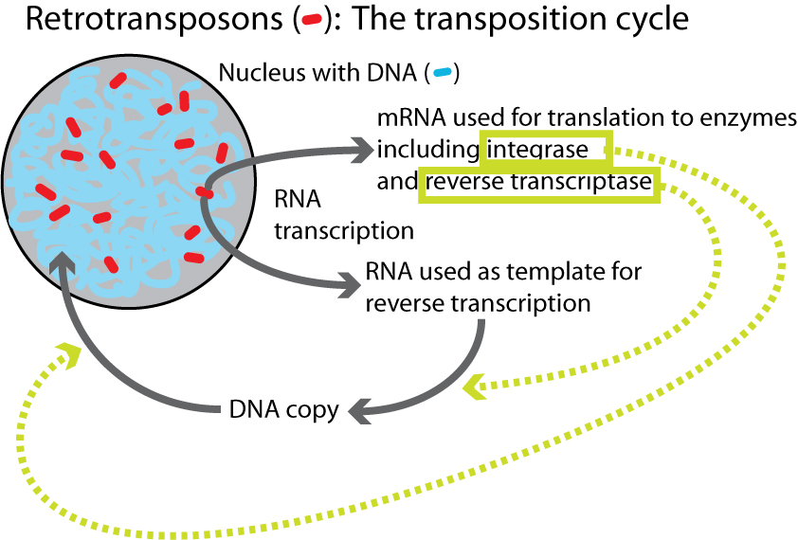

The elements have very conserved genes within them, with similar sequences being present in all plants, fungi and animals. We will amplify fragments of retroelements from genomic DNA of various species in part 1 of the practical.

As a consequence of their mode of amplification, retrotransposons are abundant and they are widely distributed over the nuclear genome.
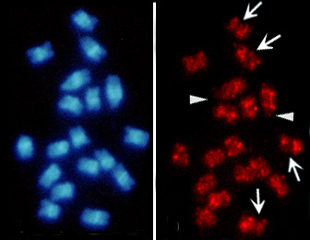
Metaphase chromosomes of sugar beet (2n=18). Left: stained blue with the DNA stain DAPI. Right: after in situ hybridization of a retroelement probe.
Retrotransposons have a characteristic structure with blocks of genes and flanking regions. As an example of a typical class, the Metaviridae or Ty3-gypsy-like elements have three open reading frames, gag, rt and int, flanked by Long Terminal Repeats or LTRs:
gag
LTR
LTR
rt
int

A stretch of nuclear DNA including a retrotransposon can be represented as follows:
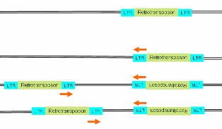

In accessions that have diverged from this progenitor, extra retrotransposons may have been inserted in the nuclear DNA flaking the original element. Here are examples of three accessions derived from the above:

The first accession is unchanged, while the second and third habe additional elements inserted at different distances from the original. Using PCR with primers represented by which face outwards from the retroelement, insertional polymorphisms can be detected. The second part of the practical will amplify and analyse inter-retroelement amplified polymorphisms (IRAPs) from genomic DNA of several accessions of different crop species.
Since retroelement insertions may occur at many points in the genome, multiple bands are found on gels. Since products can be any length, agarose gels can be used, but the PCR program, type of Taq polymerase and DNA quality can be critical to getting good results.

The gel (right) shows multiple and polymorphic bands derived from banana.

While not as specific and robust as
AFLP or microsatellite (SSR) bands,
IRAP bands are much more robust than
RAPD methods.

Practical Requirements

DNA
For both amplification of conserved genes and retroelement fragments and for IRAP analysis, DNA from the species of interest must be isolated and the quality and quantity should be measured by both gel electrophoresis and by spectroscopy. The results should be carefully documented.

Dilute the DNA to a concentration of 50 ng/µl.

Primers
For isolation of conserved gene including retroelement fragments we will use the following primers:

Retroelement Isolation
Metaviridae = Ty3-Gypsy - GyRT1 and GyRT4 primer pair
GyRT1 MRNATGTGYGTNGAYTAYMG
encoding RMCVDYR
GyRT4 RCAYTTNSWNARYTTNGCR
encoding YAKLSKC
(See Friesen N, Brandes A, Heslop-Harrison JS. 2001. Diversity, origin and distribution of retrotransposons (gypsy and copia) in conifers . Molecular Biology and Evolution 18 : 1176-1188. and others.)

Pseudoviridae = Ty1-copia - and primer pair
Cop1F ACNGCNTTYYTNCAYGG
encoding TAFLHG and
Cop1R ARCATRTCRTCNACRTA
encoding YVDDML

LINE element: Bel1MF and Bel1MR primer pair
BEL1MF RVNRANTTYCGNCCNATHAG
encoding [E/D/K/N/S][E/D/N] FRPIS
BEL2MR GACARRGGRTCCCCCTGNCK
encoding RQGDPLS
PCR products should be approximately 410bp.
(Kubis SE, Castilho AMMF, Vershinin AV, Heslop-Harrison JS. 2003. Retroelements, transposons and methylation status in the genome of oil palm (Elaeis guineensis ) and the relationship to somaclonal variation. Plant Molecular Biology 52 : 69-79) AND (Alix K, Heslop-Harrison JS. 2004 . The diversity of retroelements in diploid and allotetraploid Brassica species. Plant Molecular Biology 54 : 895-909)

See www.molcyt.com under sidebar methods/techniques then Isolation of Retroelements for more details and references

IRAP analysis
The following primers will be used in various combinations for IRAP analysis. These have been selected to be widespread in many different species:

Name | Tm | Retrotransposon source | Sequence | Accession, position
Nikita | 58 | Nikita → | CGCATTTGTTCAAGCCTAAACC | AY078073 AY078074 AY078075 1-22
Reverse TY1 | 42 | W1, W3, W7, W8 | CCYTGNAYYAANGCNCT | AF416815 AF416816 AF416817 AF416818 1-17
Reverse TY2 | 36 | W1 , W3, W7, W8 | TRGTARAGRAGNTGRAT | AF416815 AF416816 AF416817 AF416818 252-269
LTR6149 | 61 | BARE-1 → | CTCGCTCGCCCACTACATCAACCGCGTTTATT | Z17327 1993-2012
LTR6150 | 62 | BARE-1 ← | CTGGTTCGGCCCATGTCTATGTATCCACACATGTA | Z17327 418-439
5' LTR1 | 63 | BARE-1 ← | TTGCCTCTAGGGCATATTTCCAACA | Z17327 1-26
Alternative primers
5' LTR2 | 58 | BARE-1 ← | ATCATTCCCTCTAGGGCATAATTC | Z17327 314-338 7417-7441
3' LTR | 69 | BARE-1 → | TGTTTCCCATGCGACGTTCCCCAACA | Z17327 2112-2138
Sukkula | 66 | Sukkula → | GATAGGGTCGCATCTTGGGCGTGAC | AY054376 4301-4326
COPIAR |  |  | TTG AAC CCC TTT TGA TGT AT
COPIAF |  |  | GAT GCT CCT TGC CTA TGC TA

IRAP reference: see Teo CH, Tan SH, Ho CL, Faridah QZ, Othman YR, Heslop-Harrison JS , Kalendar R, Schulman AH. 2005. Genome constitution and classification using retrotransposon-based markers in the orphan crop banana. Journal of Plant Biology 48(1) : 96-105.

We can also use primers from the ends of simple sequence repeats to amplify with or without the IRAP primers:

REMAPGAn GAGAGAGAGAGAGAGAGAGG
REMAPTACn TACTACTACTACTACTACTACC

Conserved gene primers

Cellulose synthase
Mcell172 F CCA TTT ATG TGG GCA CTG G
McellIT2 R CCC CAT TCT GTC TTG TCT TC

Drought responsive element binding factor: (Shinozaki & colleagues)
DREBF1F GCC ATG CAA ATG TCT AAA ACC
DREBFIR CCC GCA AGG CTC AAC TTC

mtDNA nad1 b/c exons (Demesure, Sodzi, and Petit 1995)
NAD1R GGA GCT CGA TTA GTT TCT GC
NAD1F GCA TTA CGA TCT GCA GCT CA

Cu/Zn superoxide dismutase
CUZNSODF GGN TGY ATG WSN CAN GGN CC
CUZNSODR MCN GGN GGN GCN AAW GGN AC

MYC Anthocyanin regulatory R-S protein
MYC-F TCATCACCGGAGATGCCACGG
MYC-R TCCTCGACGACACCACACACG
Melting temperature: 62
Product length: ~448

CHS Chalcone synthase
CHS-F TCT CCG ACG CCT TCA GCA CG
CHS-R AAC ATG GAG CGG AGC CTG CG
Melting temperature: 56
Product length: ~501

DFR Dihydroflavonol-4-reductase (EC 1.1.1.219) (DFR) (Dihydrokaempferol 4- reductase).
DFR-F TGT CTC AAG CCA TCA GGG CCT
DFR-R GAT GTT CCG AGC GCG ATA CCC
Melting temperature: 56
Product length: ~380

Part 1: PCR with ‘Universal Primers’ – Retroelement and conserved gene isolation

Retroelement and conserved gene PCR analysis

20 µl reaction mixture contains
50 ng DNA,
1X PCR buffer,
2 mM MgCl₂,
5 pmol of each primer,
200 mM dNTP mix,
1 U Taq polymerase

.Total volume 20 µl.

The basic PCR Conditions will be as follows:

1. 94C 4min
2. 94C 1min
3. Annealing temperature 1min
4. 72C 1min – 30 cycles going back to step 2
5. 72C 1min
6. 4C hold

Products will be analysed by agarose gel electrophoresis.

Part 2: Universal Primer Marker Analysis – IRAP and REMAP: Measuring Diversity with retroelement PCR primers

PCR
The following primer combinations will be assigned to individual groups during the practical
IRAP Inter-Retroelement Amplified Polymorphisms

 | Nikita | RTy1 | RTy2 | LTR6149 | LTR6150 | 5LTR1
Nikita |  | 1 |  | 2 | 3
RTy1 |  |  |  |  | 5
RTy2 |  |  |  | 4 |  | 6
LTR6149 |  |  |  |  |  | 7
LTR6150
5LTR1

IRAP PCR is performed in a 20 µl reaction mixture containing

50 ng DNA,
1X PCR buffer (Promega, USA),
2 mM MgCl₂,
5 pmol of each primer,
200 mkM dNTP mix,
1 U Taq polymerase (Promega, USA).

Amplification is performed using PCR
94°C, 2 min;
30 cycles of
94°C, 30 s,
annealing at the appropriate T_{a} for 60 s,
ramp +0.5°C s"¹ to 72°C
72°C for 2 min + 3s per cycle;
Final extension at 72°C for 10 min.

Alternative PCR Protocol
PCR Conditions:
1 94C 4 min
2 94C 1 min
3 35C 30 sec
4 72C 45 sec repeat 3x to step 2
5 94C 1 min
6 45C 30 sec
7 72C 45 sec repeat 40x to step 5
8 72C 5 min
9 4C hold

PCR Mix: 0.1 ul Taq, 1ul each primer 10uM, total volume 12 ul.

Gel electrophoresis and scoring

In most cases, agarose gels stained with ethidium bromide are appropriate. Usually, resolution of bands below 2kb is required, so a higher percentage gel is required than usual: 2.5 or 3%. “High resolution” types of agarose can be used to increase the separation and sharpness of bands: mixtures of high-resolution and normal agarose (1 part HR to 3 parts normal) are as good as using the HR agarose (3 to 5 x more expensive) alone.

Denaturing polyacrylamide gel electrophoresis can also be used for separation of IRAP fragments.

Load the PCR product on the gels. Include enough lanes of molecular markers. Make sure your lanes are randomised – for example, do not load all African accessions at one end of the gel and all Asian accessions at the other end or band finding will become very difficult.

The stained gels are photographed with a digital camera (or conventional/Polaroid).

Each band of a characteristic molecular weight is then scored for presence or absence in each of the accessions being analysed and the results put into a spreadsheet.

Analysis
Several computer programs are available for analysis of bands, measurement of polymorphisms or genetic distances between accessions, and reconstruction/inference of phylogeny. Many of the best programs (and best-documented programs) are free: examples are PHYLIP, PowerMarker and Arlequin. Some of these will be demonstrated for analysis of our IRAP data.

Part 3: In situ Hybridization – Chromosome preparation, microscopy and sequence localization demonstrations

Day 1.
Root tip collection – glasshouse walk-around, examination of plants and discussion of collection of root tips and other material for chromosome preparation

Root tip pre-treatment – used of 8-hydroxyquinoline and of iced water

Root tip fixation – fresh 3:1 ethanol:acetic acid

Day 2.
Root tip digestion and chromosome preparation
Staining with fluorochromes
In situ hybridization outline

Day 2/3.
Examination of in situ hybridization demonstration slides.
Discussion of value of analysis.

